Due Diligence Report for Land Acquisition and Resettlement

Document Stage: Draft for team review
Project Number: 43439-KAZ
Date: July 2015

KAZ: CAREC Corridor 2
(Mangystau Oblast Section)
Investment Program
Tranche 2

Prepared by the Ministry of Investments and Development for Asian Development Bank.

The Due Diligence Report for Land Acquisition and Resettlement is a document of the borrower. The views expressed herein do not necessarily represent those of ADB’s Board of Directors, Management, or staff, and may be preliminary in nature.

CONTENTS

1. INTRODUCTION 4

2. PROJECT DESCRIPTION 5

3. OBJECTIVES OF DUE DILIGENCE AND METHODOLOGY 7
3.1 Objectives and Scope of Due Diligence 7
3.2 Methodology 7
3.3 Available LAR Documents 7

4. DUE DILIGENCE FINDINGS 8
4.1 Applicable national legislation 8
4.2 Data on land use and Land Use Plan 9
4.3 Signing of servitude agreements 11
4.4 Consultations and grievance redress 12

5. CONCLUSION AND RECOMMENDATIONS 13

ANNEX 1: Photographs of consultations 16

ACCRONYMS AND ABBREVIATIONS

ADB | - | Asian Development Bank
CAREC | - | Central Asia Regional Economic Cooperation Program
CoR | - | Committee on Roads
DD Report | - | Due Diligence Report
ha | - | hectare
Mangystau NPTsZem | - | Mangystau Land State Scientific and Production Center  for Land Management
LAR | - | Land Acquisition and Resettlement
LARF | - | Land Acquisition and Resettlement Framework
km | - | Kilometer
MFF | - | Multitranche Financing Facility
MID | - | Ministry of Investments and Development
PMC | - | Project Management Consultant
Program | - | CAREC Transport Corridor 2 Investment Program
Project | - | Zhetybai-Zhanaozen section (km 0 – km 73) of the republican road Zhetybai – Zhanaozen – Fetisovo – border of the Republic of Turkmenistan (to Turkmenbashi)
RoK | - | Republic of Kazakhstan
SPS | - | Safeguard Policy Statement

1. INTRODUCTION

- The Central Asia Regional Economic Cooperation Program (CAREC) Transport Corridor 2 Investment Program proposed by the Government of Kazakhstan for funding by the Asian Development Bank (ADB) aims to rehabilitate/upgrade the roads in Mangystau Oblast of the Republic of Kazakhstan (RoK).

- The CAREC Transport Corridor 2 Investment Program (the Program) will reconstruct roads in Mangystau Oblast of CAREC Corridor 2, which connect Kazakhstan to Azerbaijan, Europe and Turkey through the Caspian Sea to the west; to the Russian Federation to the north; to Uzbekistan to the southeast; and to Turkmenistan to the south. The rehabilitation/upgrading of this road corridor will bring about (i) increased trade and competitiveness, (ii) lower transport costs, (iii) increased mobility and accessibility of local residents to economic opportunities and social services; and (iv) improved governance. The Government of RoK has requested the ADB to provide financing for the Tranches 1 and 2, which focuses on upgrading the Aktau – Beineu road, as well as Zhetybai – Zhanaozen section of the Zhetybay – Zhanaozen – Fetisovo – border with the Republic of Turkmenistan road.

- The Program is estimated at $1.1 billion. ADB has been requested to finance up to $800 million through a Multi-tranche Financing Facility (MFF) to be divided into two tranches with a total of 14 civil work packages as follows:

Tranche 1:
Package 1 (km 372.6 – km 422)
Package 2 (km 422 – km 472.8)
Package 3 (km 472.8 – km 514.3)
Package 4 (km 574 – km 632.3)

Tranche 2:
Package 5 (km 632.3 – km 675.6)
Package 6 (km 675.6 – km 719)
Package 7 (km 719 – km 754)
Package 8 (km 754 – km 802.27)
Packages 9 -10 Zhetybai-Zhanaozen (km 0 – km 73) section of the republican road Zhetybai – Zhanaozen – Fetisovo – border of the Republic of Turkmenistan (to Turkmenbashi) (234 km) including cross-border infrastructure facilities, has been included in Tranche 2.

- The road sections covered under Tranche 1 has been upgraded from Category III to Category II. Civil works will include the construction of two-lane asphalt pavement, reconstruction of culverts and bridges that do not conform to engineering requirements of the new road, overpass, and road signs and signal posts along accident prone spots. Most of the civil works for the road will follow the existing alignments.

- Tranche 2 is a road upgrading activity, comprising a total of 169.97 kilometers that can be divided, for technical reasons, into 2 sections. The road will be rehabilitated and partly constructed in accordance with the national highway categories:
- Section 1 involves the entire route between Shetpe bypass start (km 632.3), to the end of Shetpe bypass (km 644), and continuing to Zhetybai bypass (km 711-719) until joining the national highway from Zhanaozen and Turkmenistan to Aktau (km 719);
- Section 2 involves the stretch between Zhetybai junction (km 719) westwards to Aktau urban periphery, at the junction at km 802.27.

- The section km 514.3 – km 573.6, financed by GoK, is considered as the associated facility to this project. It involves the upgrading an existing route starting at a small settlement known as Sai-Utes (near km 514) and then proceeding westwards until the existing road is covered with a blacktop layer. The section Zhetybai-Zhanaozen (km 0 – km 73) of the republican road Zhetybai – Zhanaozen – Fetisovo – border of the Republic of Turkmenistan (to Turkmenbashi) is also included in Tranche 2.

- The Land Acquisition and Resettlement Framework (LARF) for the MFF for CAREC Corridor 2 (Mangystau Oblast Section) Investment Program was developed in August 2010 based on the relevant laws on land acquisition and resettlement (LAR) in the RoK and the provisions of the 2009 Safeguard Policy Statement (SPS) of ADB. Further on it was reviewed and updated in November 2012, and endorsed by the Ministry of Transport and Communications through the Committee on Roads (CoR). During the approval of the MFF, the CoR was under the Ministry of Transport and Communications, however following restructuring of ministries in 2014, the Ministry of Transport and Communications’ functions and the CoR respectively were moved to Ministry of Investments and Development (MID). Second update of the LARF was finalized in June 2015.

- This Due Diligence Report for Land Acquisition and Resettlement (DD Report) relates to the section Zhetybai-Zhanaozen (km 0 – km 73) of the republican road Zhetybai – Zhanaozen – Fetisovo – border of the Republic of Turkmenistan (to Turkmenbashi) (Project) included in the Tranche 2 of the CAREC Corridor 2 (Mangystau Oblast Section) Investment Program, and was prepared for ADB. This DD Report has been prepared in order to assess if there are any LAR impacts associated reconstruction of the Zhetybai-Zhanaozen road section (km 0 – km 73), and confirm that there are no pending or unresolved issues that may impact the proposed Project. DD Report is structured and presented as follows: Section 1 provides baseline information, Section 2 presents details of proposed Project, Section 3 addresses objectives and methodology applied for due diligence, Section 4 specifies the findings, and Section 5 covers conclusion and recommendations.

2. PROJECT DESCRIPTION

- The RoK through the MID is planning to renovate Zhetybai-Zhanaozen (km 0 – km 73) section of the republican road Zhetybai – Zhanaozen – Fetisovo – border of the Republic of Turkmenistan (to Turkmenbashi). It is expected that funding for the civil works will be provided by the ADB under the MFF of the CAREC Transport Corridor 2 Investment Program.

- Republican road Zhetybai - Zhanaozen - Fetisovo - border of the Republic of Turkmenistan is a part of the international road route from Turkmenistan to Russia. The section of the road to be reconstructed runs through the deserted and sparsely populated areas in all its way from a junction at Zhetybai village to Zhanaozen town. The route of the proposed Project road passes through the lands of Karakiya district of Mangystau oblast and lands subordinated to local authorities of Zhanaozen, as well as the railway lands.

- The condition of the existing road is poor, as the roadbed does not meet the standards of Construction Norms and Regulations (SNIP) for height and slopes. Pavement is deteriorated, and is subject to reconstruction as well as widening.

- Design for the project was developed by the institute OJSC «KazdorNII» and LLP "Design-Research Institute «Kazdorproject» in 2010-2012. The Project includes reconstruction of the existing republican road of category III, Zhetybai - Zhanaozen - Fetisovo - border of the Republic of Turkmenistan section 0-73 km, to the category I-B road, which within the Zhanaozen bypass will be of Category II and the section of existing road to be rehabilitated in Zhanaozen will remain of Category III (as only pavement rehabilitation works are envisaged there). The length of the road in its current route is 73km, while the length of project road section is 63 km. Reduction of the length of the road is due to arranging the 5 km bypass of Zhanaozen and subsequent decrease of overall road length by 10 km.

- The design for Project road includes:
- Construction of the road, entrance to Zhanaozen;
- Construction of two-level transport interchange on the bypass of the town of Zhanaozen;
- Construction of an overpass at the two-level transport interchange on the bypass of the town of Zhanaozen;
- Construction of an overpass over the railway on the section Zhetybai-Uzen;
- Construction of an industrial complex of buildings and structures of road maintenance unit in Zhanaozen;
- Reorganization and protection of gas-oil pipelines.

- The location of the proposed project road section Zhetybay - Zhanaozen in CAREC Corridor 2 within Mangystau Oblast of Kazakhstan is demonstrated on the Figure 1 below (Project road section is located in the red circle area).

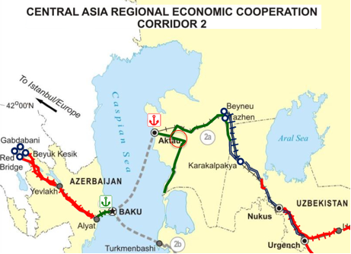

- During the construction phase, land may also be needed temporarily for batching plants, field offices / workers’ camps, and temporary bypasses. However, civil works contracts will require the Construction Contractor(s) to be responsible for the temporary acquisition and reinstatement of all land required outside of the right of way for construction camps, offices, borrow pits, materials storage sites, materials processing sites and haul roads. Construction Contractor(s) is (are) assumed to prefer to rent State land, rather than private property, during implementation of construction works. In addition, temporarily used lands are required to be returned to their original state after work is concluded.

3. OBJECTIVES OF DUE DILIGENCE AND METHODOLOGY

3.1 Objectives and Scope of Due Diligence

- Due diligence was conducted in February – June 2015 by the international and national consultants involved by the Project Management Consultant (PMC), with assistance of CoR.

- During due diligence process the consultants reviewed project documents provided by Design Consultant, PMC, CoR, including design documents developed by the institute OJSC «KazdorNII» and LLP "Design-Research Institute «Kazdorproject» in 2010-2012, Land Use Plan developed by the Mangystau Land State Scientific and Production Center for Land Management (Mangystau NPTsZem) in March 2015, as well as copies of servitude agreements provided by the CoR.

- The primary objective of the due diligence is to verify the status of the plots, for which according to the Land Use Plan no acquisition is required, and to identify, and plan appropriate measures to address outstanding compliance issues (if any). The main objectives of the due diligence include:
- Identify status of impact and the need for acquisition of the land plots located within the corridor of impact of the Project;
- Review preliminary information on potential land use available in design documents developed by the institute OJSC «KazdorNII» and LLP "Design-Research Institute «Kazdorproject» in 2010-2012;
- Review the Land Use Plan developed by the Mangystau NPTsZem in March 2015;
- Review the servitude agreements provided by CoR in June 2015;
- Review the legal framework based on which the property was acquired, compare that with ADB SPS requirements with respect to land acquisition and resettlement; and
- Prepare list of recommendations and if needed a corrective action plan including necessary remedial actions.

3.2 Methodology

- The following approach and methodology was adopted for conducting due diligence for land acquisition for Project road to define the LAR impacts:
- Review of available information and conduct reconnaissance to collect and assess the baseline conditions;
- Regulatory review in order to understand the applicable local legislation, regulatory frameworks and procedures;
- Comparison of LAR process with ADB SPS requirements;
- Collecting and review of available data on land use and ownership in the corridor of impact of the Project road;
- Collecting data and obtain clarification on pending and unresolved issues with respect to the land plots located in the corridor of impact of the Project road;
- Conduct meetings and discussion with akimat(s) and persons involved in acquisition process and other relevant entities.

3.3 Available LAR Documents

- Design documents were developed by the institute OJSC «KazdorNII» and LLP "Design-Research Institute «Kazdorproject» in 2010-2012. Land Use Plan was developed by the Mangystau NPTsZem in March 2015 following the request from CoR. The reference on servitude agreements signed with land plot owners was provided by the CoR in June 2015.

4. DUE DILIGENCE FINDINGS

4.1 Applicable national legislation

- In Kazakhstan, land is owned by the State but can be transferred, sold or rented to individuals for short-term (less than 5 years) or long-term (5-49 years) use. The State can acquire privately-owned/used land only for specific uses, including road transport infrastructure construction, and only after compensating the owner for the asset and other losses.

- There are several of laws regulating land and property related relations, and in particular LAR processes, including land acquisition for state needs. The major legal document that provides basis for land rights is Constitution of the Republic of Kazakhstan. The Land Code (RK Code No. 464-IV adopted on 20 June 2003, last amendment dated 9 December 2014) establishes the foundations, conditions and limits for modifying or terminating ownership of land and land-use rights, describes the rights and responsibilities of landowners and land users, and regulates land relations. The Law on State Property (№ 413-IV LRK adopted on 1 March 2011, last amendment dated 29 December 2014) provides details on process of compulsory acquisition of land plots, including approval of a Decree on compulsory acquisition of land or other real property in connection with the seizure of land plot for state needs, and further steps to be implemented following issuance of such a Decree. The Law on Housing Relations (№ 94-I, adopted on 16 April 1997, last amendment dated 10 January 2015) regulates the issues on provision of housing to the property during the demolition of a residential building as a result of involuntary acquisition of land plots for state needs.

- Detailed analysis of RoK legal framework, comparison with ADB SPS land acquisition and resettlement related requirements are provided in the LARF prepared for MFF in August 2010 and updated in November 2012. The most recent update was made in June 2015 and the document is currently submitted for ADB approval. Below in the section are provided details on imposition of servitudes in accordance with the Land Code of the RoK.

- The Land Code provides details on imposition of servitudes, and in particular in its Article 67 states that right to servitude may arise in the following cases:
- directly from the legislative act;
- on the basis of agreement between the authority and land owner/user;
- on the basis of the act / resolution issued by the local government;
- on the basis of court decision;
- in other cases provided by the legislation of the Republic of Kazakhstan.

- In addition, the Article 69 provides details on the right of limited use of neighbouring or other land plot and establishes that the public servitudes may be established in the cases as necessary for serving the interests of a state and local population, without seizure of land plots, on the basis of decisions made by the local executive bodies of oblasts, rural settlement, village, rural district within their competence upon granting land plots. It also indicates that the public servitudes may be established for “use of the land plot for the purposes of installation and operation of the public utilities, pipelines and networks, power lines, as well as the objects of transportation infrastructure…” and for “use of land plot for the purposes of placement and operation of the main pipeline infrastructure” and “in other ways, linked with public and state interests” (paragraph 4 of the Article 69). An owner or land user of a land plot encumbered with a public easement shall have the right to require a reasonable charge from the state authorities that established a public easement where the establishment of an easement leads to substantial difficulties in using a land plot (paragraph 7 of the Article 69). Article 72 envisages that in the cases provided by the legislative acts of the RoK or by agreement of the parties, other servitudes may be established (except those mentioned in the Land Code).

- Article 74 addresses the process of the servitude termination, which includes the following options:
- the servitude shall be terminated in a result of the right holder’s refusal, long-termed non-working (3 years), expiry of a period, on the basis of agreement between parties, on the basis of the court decision and on the other basis, provided by the legislative acts of RoK.
- the public servitude may be terminated in a case of absence of the public needs for which it was established, by decision of the local executive body on a cancellation of servitude.
- in the unilateral manner, the action of servitude shall be terminated on the grounds, provided by the legislative acts of RoK or by agreement of the parties.
- the servitude may be terminated after demand of the private owner or land user in a judicial proceeding, in connection with its improper use by the possessor of a right, as well as due to lack of the grounds, on which it was established.
- in cases, when the servitude is established for a specified period, its action shall be terminated upon expiry of established period, unless otherwise provided by agreement of the parties. In the cases when the servitude is established before claiming or for an indefinite term on the basis of agreement, the action of servitude shall be terminated upon expiry of one month from the moment of claim on a servitude’s termination by the owner of real property encumbered by the servitude.

- As to the registration of servitude (Article 75), the accrual, change and termination of servitudes shall be subject to the state registration in a legal cadastre, which grant the right of limited intended use of the other’s land plot to the right holder. Upon the registration of servitude, the documents shall be accompanied by the plan of a land plot on the basis of which the servitude is accrued, with a boundaries mapping of the servitude’s action, notarized by the person provided the servitude. The servitudes arising on the basis of legislative acts, as well as the other servitudes which are not the objects of registration in accordance with the legislative act of RoK on a state registration of rights to real property shall not be subject to the state registration.

4.2 Data on land use and Land Use Plan

- The potential DPs for this Project were originally identified based on the feasibility study and design for the project that was developed by the institute OJSC «KazdorNII» and LLP "Design-Research Institute «Kazdorproject» in 2010-2012. In January 2015 the CoR MID has submitted the letter to the director of Mangystau NPTsZem with the request to prepare a Land Use Plan and define boundaries of the land plot required for location and maintenance of the Project road section (CoR letter 23-23-02/27 dated 6 January 2015).

- Based on the final design, the Land Use Plan was prepared by the Mangystau NPTsZem and approved in March 2015 and corridor of impact was precisely defined and DPs revealed. The Land Use Plan was finalized on 16 March 2015.

- According to the Land Use Plan the Project road was divided into two sections:

- Section No 1 of the road, which is of I-B category with 4-lane carriageway, and which is the continuation of existing road and is located on the state reserve lands of Mangystau rayon (length of the Section No 1 is 2,877.0 m and the total area of the land plot is 20.1090 ha);
- Section No 2 of the road runs from the boundary of Mangystau rayon and until the boundary of Zhanaozen town (length of the Section No 2 is 37,899.0 m and the total area of the land plot is 265.3251 ha).

- Total length of the road section subject to reconstruction is 40776 m, and the total area provided to the CoR comprises 285.4341 ha.

- For the reconstruction of the road two land plots were already provided before, which includes one plot with total area of 11.1680 ha (cadastre number 13-197-021-071) and the second plot with total area of 131.7 ha (cadastre number 13-197-021-136).

- The additional land required for the Section No 1 comprises 8.9410 ha, in particular:
- Lands of Zhetibay village – 6.3896 ha;
- Lands of Munayshy village – 1.8143 ha;
- Land plot owned by JSC “Mangystaumunaigas” – 0.7371 ha.

- Additional land required for the Section No 2 comprises 133.6251 ha, in particular:
- State reserve lands – 93.2996 ha;
- Land of JSC “Kazakhtelecom” – 0.5771 ha;
- Land of “Tasbulat Oil Corporation” Ltd. – 0.5483 ha
- Land of “Kazakh gas-processing plant” Ltd. – 0.1681 ha;
- Land of Nisanov K. – 0.0840 ha;
- Land of “Reseach Extraction “KazMunaiGas”” JSC – 0.1294 ha;
- Land of “Ecoterra” Ltd. – 0.0120 ha;
- Land of JSC “KazTransoil” – 0.0560 ha.

- The total additional land provided to the CoR MID comprises 142.5661 ha.

- Following the provisions of the Land Code of the RoK, in the Land Use Plan it was recommended to sign the servitude agreements with the following legal entities: JSC “Mangystaumunaigas”, JSC “Kazakhtelecom”, “Tasbulat Oil Corporation” Ltd., “Kazakh gas-processing plant” Ltd., Nisanov K. (individual entrepreneur), “Reseach Extraction “KazMunaiGas”” JSC, “Ecoterra” Ltd., JSC “KazTransoil” in order to obtain the right for temporary limited use of their land plots in case of need.

- According to the Land Use Plan, the overall area provided to CoR for the reconstruction of the Project road comprises 140.2541 ha.

- The proposed road is passing through desert and semi-desert areas. The land plots owned by abovementioned legal entities are located along the project road, and are used for commercial purposes for locating the infrastructure (oil pipeline, gas pipeline, water pipeline, communication cables, power lines, etc.). There are no structures or plants located on these land plots.

- According to the review of available information and field reconnaissance, and confirmation from CoR no other full or partial permanent of temporary LARP impacts are expected due to proposed project, including loss of access to land / structures / other property / sources of income / other areas of public use or specially protected areas.

4.3 Signing of servitude agreements

- The CoR has agreed with the Land Use Plan and following its recommendation and proceeded with negotiating and signing the servitude agreements. Details on signed servitude agreements are provided in the table below compiled based on the reference provided by CoR. During negotiations it was revealed by CoR that two on the mentioned land plots will not be impacted (see lines 7 and 9 in the table below), while the servitudes with two another companies were needed (see lines 10 and 11 in the table below). The servitude agreements were negotiated by the CoR, the owners of the plots were informed on the provisions of the servitude agreements and details on the project.

Table: Summary data on signed servitude agreements

№ | Name of company / legal entity | Included in Land Use Plan | Area under servitude, ha | Infrastructure | Status of servitude | Duration of servitude  (Dates of commence-ment and end) | Payment for servitude, KZT
1 | «Mangystaumunaigas» JSC | Yes | 0,7371 | Gas pipeline,  oil pipeline | Signed on 11.06.2015 | 11.06.2015 - 08.12.2028 | Unpaid
2 | «Kazakhtelecom» JSC (Mangystau rayon) | Yes | 3,7146 | Communication line | Signed on 21.05.2015 | 21.05.2015 -31.12.2017 | Unpaid
3 | «Kazakhtelecom» JSC  (Karakia rayon) | Yes | 0,5771 | Communication line | Signed on 21.05.2015 | 21.05.2015 - 31.12.2017 | Unpaid
4 | «Tasbulat Oil Corporation» LLC | Yes | 0,5483 | Water pipeline,  gas pipeline | Signed on 27.05.2015 | 27.05.2015 -31.12.2017 | Unpaid
5 | «Kazakh gas-processing plant» LLC | Yes | 0,1681 | Gas pipeline | Signed on 10.06.2015 | 10.06.2015 - 31.12.2017 | Unpaid
6 | Individual Entrepreneur  Nisanov K. | Yes | 0,840 | Power lines,  water pipeline | Signed on 19.05.2015 | 19.05.2015 - 31.12.2017 | Unpaid
7 | «KazMunayGas» JSC NC | Yes | 0,1294 | none | Not signed  (not needed) | N/A | N/A
8 | «Ecoterra» LLC | Yes | 0,0120 | Power lines | Signed on 21.05.2015 | 21.05.2015 - 31.12.2017 | Unpaid
9 | «KazTransOil» JSC | Yes | 0,056 | Supports for high-voltage lines, anchor and interme-diate pillars | Not signed  (not needed) | N/A | N/A
10 | «KTZh» JSC NC | No | 0,6994 | Railway | Signed on 22.05.15 | 22.05.2015 -31.12.2017 | Unpaid
11 | «Kamenistoe - oil» LLC | No | 0,0148 | Gas pipeline | Signed on 03.06.2015 | 03.06.2015 - 31.12.2015 | Unpaid

- Terms and conditions of the servitude agreements were discussed and agreed with each owner of the land plot to be temporarily used for the project. The servitude agreements are based on the provisions of the Land Code and are signed “on the basis of agreement between the authority and land owner/user”.

- During implementation of construction works and further operation of the road the owners of the land plots will not face restrictions in using their land plot in accordance with its designated and/or actual purpose of use, as the servitude agreement is signed for those parts of the land plots on which the underground infrastructure (gas pipeline, oil pipeline, water pipeline, communication cables and power lines). No fences or other structures will be placed on these land plots during the works or the access to the land plots will not be restricted on any other way. The owners of the land plots will have free access to their lands.

- All of the servitude agreements are unpaid (as the land owners do not have any losses) and envisage temporary access to the land plot. Moreover, rehabilitation and improvement of the road will positively impact the business of these entities and will enable them to commute easier to their land plots and infrastructure. During the negotiations, all the owners expressed their readiness to sign the agreements. The servitude agreements were signed in May-June 2015 (dates are provided in the table above).

4.4 Consultations and grievance redress

- Initial public consultations regarding the proposed Project were carried out during design preparation. Two public consultations were held in April 2010. The meetings were held in Aktau (21 April 2010, in the Conference Hall of the Technical University) and in Shetpe (22 April 2010, in the Akimat Conference Room). Besides the mentioned consultations there were two more, one in Zhetibay and one in Shetpe in June 2011. The first event was attended by 29 participants including Government officials, national and international specialists on traffic management, engineering, environment, economics and resettlement, as well as representatives of civil society and one NGO. The second event was attended by 40 participants, including Government officials, national and international specialists on environment, economics and resettlement, as well as representatives of civil society. In addition to the above-mentioned consultations, two more consultations were carried out – one in Zhetibay and another in Shetpe in June 2011. Later, on 8 April 2014 consultation/meeting was carried out in Shetpe, Kosbylak with the 2 permanently affected HH whose houses will be relocated. The meeting was conducted by International and local community liaison specialists from PMC. The questions revolved around the details of the compensation payment, relocation, complaints and grievance redress options. In July 2014 PMC international and national consultants carried out consultations with participation of 20 DPs in order to finalize the LARP.

- The public consultations were also conducted with respect to the Zhetybai-Zhanaozen (km 0 – km 73) section of the republican road Zhetybai – Zhanaozen – Fetisovo – border of the Republic of Turkmenistan (to Turkmenbashi) (Project) included in the Tranche 2 of the CAREC Corridor 2 (Mangystau Oblast Section) Investment Program, and were focused on providing the information on proposed Tranche 2 with a special emphasize on environmental and resettlement issues. Two public consultations were carried out on 3 March 2015 in Zhetybai and Zhanaozen communities. The announcements on the public consultations were published in the local newspaper “Ogni Mangystau” (in Russian) on 10 February 2015, local newspaper “Mangystau” (in Kazakh language) on 12 February 2015, as well as posted to the website of CoR. Overall, more than 125 participants attended two public consultations, including representatives from state entities, owners of lands/property and businesses located nearby the project road, and civil society. The information brochure summarizing the LAR approaches, requirements, grievance redress mechanism was developed and distributed during the public consultations. The CoR, Mangystau Zhol Laboratory, Design Consultant and PMC specialists and consultants also took part in consultations.

- The representative of Design Consultant JSC KazdorNII delivered a presentation on engineering and technical details of the proposed road reconstruction and provided information on design solutions related to road section, envisaged ramps, interchanges, bypass, cattle passes, rest areas, etc. Further on the presentation on environmental analysis has been delivered, providing details on impacts expected during the project activities as well as mitigation measures that will be included into the design documentation. Afterwards the presentation on land acquisition and resettlement approaches has been provided, including information of on relevant legislation and approaches, details of entitlements and compensation, grievance redress mechanism, roles and responsibilities of entities involved in LAR activities, as well as ongoing LAR activities and next steps. Attendees actively participated in the discussion. Questions and comments revolved around details of the project activities, including schedule of construction activities, opportunities for jobs, information on the process of land acquisition, etc. Representatives of Mangystau Zhol Laboratory, Design Consultant and PMC responded to the questions and provided clarifications. In addition to public consultations, separate meetings were carried out by PMC with representatives of relevant Akimats, Mangystau NPTsZem, as well as discussions were held with heads of peasant farms, representative of roadside business. The photographs made during the public consultations are provided in the Annex 1.

- Negotiations related to servitude agreements were carried out between JSC “NC KazAutoZhol” (entity authorised by CoR) and management of the legal entities that own the land plots. All the owners of the land plots are legal entities, mostly involved in mining and telecommunication sectors and have legal departments or lawyers in their staff. The draft versions of servitude agreements were reviewed by the owners of the land plots (including their respective legal representative in most of the cases) and were discussed between the parties. Terms and conditions of the servitude agreements were discussed and agreed with each owner of the land plot to be temporarily used for the project. The owners were also explained that the land plots will remain their property. They will have the free access to their land plots and will continue to use them with their initial purpose of use. The consultations and negotiations with the owners of the land plots (for which the servitude agreements were signed) were carried out in an atmosphere free of intimidation or coercion, the parties were provided with opportunity to express their views and suggestions.

- During due diligence activities, the PMC consultants tried their best to meet and consult with DPs, however, despite the efforts applied by the PMC, it was impossible to establish a contact with DPs, except representative of one of the affected legal entities (Individual Entrepreneur Nisanov K.). The representatives of the affected legal entity was met before the servitude agreement was developed and negotiated, and was informed on LAR approached as per ADB SPS, including entitlements for compensation, consultation and grievance redress mechanism as per updated LARF.

- Grievance redress mechanism was developed to ensure an effective and systematic mechanism for the Projects in responding to queries, feedbacks and complaints from affected persons, other key stakeholders and the general public. The grievance redress process was updated in the LARF in accordance with the Guideline on Grievance Redress Mechanism on Environment and Social Safeguards for Road Sector Projects approved by the CoR in August 2014.

5. CONCLUSION AND RECOMMENDATIONS

- As a result of the review of available documents, plans and references provided by CoR it can be concluded that no permanent land acquisition is required in the corridor of impact of proposed Project road. The LAR impacts are expected to be limited to temporary use of the land plots owned by 9 legal entities and respectively 9 temporary servitude agreements were signed with owners of the land plots (legal entities that have various infrastructure located nearby or under the road).

- The servitude agreements were drafted in accordance with the Land Code of Kazakhstan and are considered as the agreement (on servitude) signed between the acquiring authority and land owner/user. The public servitudes may be established in the cases as necessary for serving the interests of a state and local population, without seizure of land plots, on the basis of decisions made by the local executive bodies of oblasts, rural settlement, village, rural district within their competence upon granting land plots. Public servitudes may be established for use of the land plot for the purposes of installation and operation of the public utilities, pipelines and networks, power lines, as well as the objects of transportation infrastructure; for “use of land plot for the purposes of placement use of land plot for the purposes of placement and operation of the main pipeline infrastructure” and “in other ways, linked with public and state interests”.

- The servitude agreements were negotiated by the JSC “NC KazAutoZhol” (entity authorized by the CoR). According to CoR, the owners of the plots were informed on the provisions of the servitude agreements and all relevant details on the project. Terms and conditions of the servitude agreements were discussed and agreed with each owner of the land plot to be temporarily used for the project. The consultations and negotiations with the owners of the land plots (for which the servitude agreements were signed) were carried out in an atmosphere free of intimidation or coercion, the parties were provided with opportunity to express their views and suggestions. All of the servitude agreements are unpaid and envisage temporary access to the land plot. The agreements were signed in May-June 2015.

- Although no permanent LAR impacts are expected, the following recommendations are made to ensure smooth implementation of works on the land plots for which the temporary servitude agreements were signed.
- CoR should monitor completion of re-registration process and issuance of appropriate acts for servitudes, should such registration be deemed necessary. CoR in cooperation with relevant state authorities (including Akimats of Karakiya and Mangystau rayons, Mangystay oblast department on land relations, etc.) should assist in re-registration process and cover all expenses related to registration procedures; this should be properly documented in quarterly monitoring reports submitted to ADB by COR.
- Advance notice shall be provided to the owners of the land plots provided in accordance with the servitude agreements prior to commencement of works on their plots (30 days);
- CoR should monitor and ensure that in case any damages are expected to be caused during use of the land plots provided in accordance with the servitude agreements, the appropriate compensation is calculated according to the provisions of LARF and ADB SPS, respective documents are agreed with ADB, and the payment is provided to the owner prior to commencement of works on the particular land plot;
- CoR should monitor that the land plots provided in accordance with the servitude agreements are properly restored to their original state after the works are completed.
- Submit quarterly monitoring reports to ADB for disclosure.

- In addition the following recommendation are made to minimise potential LAR impacts and ensure awareness on and use of grievance redress mechanism for the population of Project area:
- In case new LAR-impacts or any unanticipated resettlement impacts emerge at any stage of Project implementation, CoR, JSC “NC KazAutoZhol”, PMC shall ensure that LARP is prepared in accordance with the LARF (as updated) and ADB SPS (2009); and COR to ensure availability of sufficient resources to address the issues. COR will submit the LARP to ADB for review and disclosure and until such planning documents are formulated, approved and disclosed COR will not implement the specific project components for which involuntary resettlement impacts are identified.
- CoR, JSC “NC KazAutoZhol”, PMC with support from Construction Supervision Consultant should monitor temporary land use and ensure that in case the additional land plots are required for temporary use during construction activities, the Construction Contractor(s) obtains relevant agreements allowing use of such lands. Moreover, after completion of civil works the lands taken for temporary use shall be restored to their original conditions by Construction Contractor(s) and rent fees shall be fully paid to the owners of those land plots;
- JSC “NC KazAutoZhol” in cooperation with PMC should monitor grievance redress process, ensure continuous liaison with Grievance Focal Points from Akimats as well as CoR, and regularly inform ADB on actions taken on received complaints, their status and constraints in resolving those complaints;
- Information on progress of works envisaged by the Project should be disseminated in affected communities, so as the interested public is informed and aware of ongoing and planned works.

ANNEX 1: Photographs of consultations

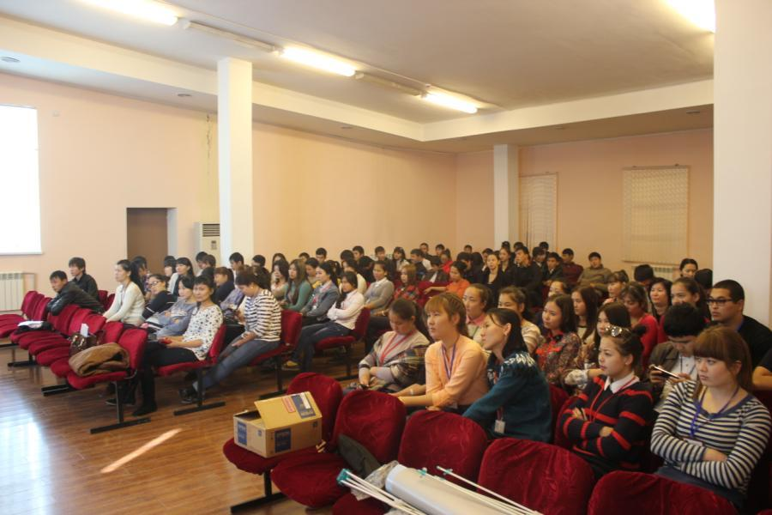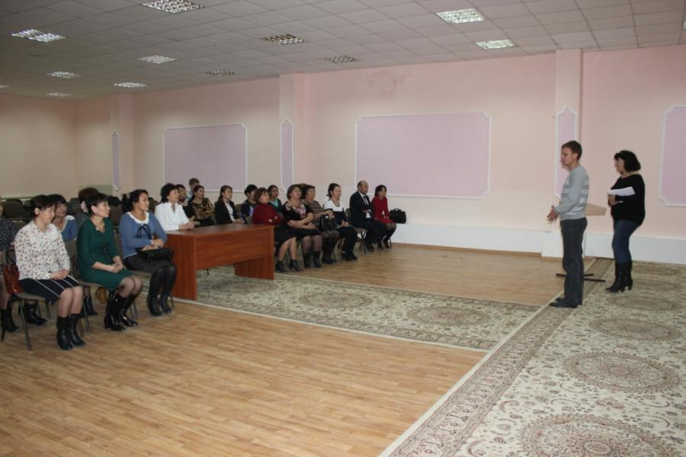
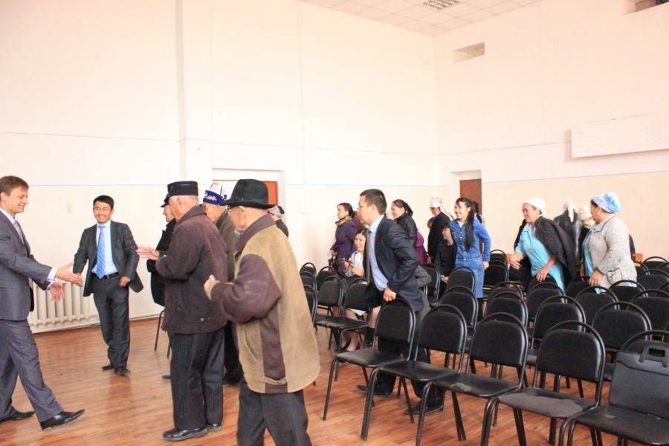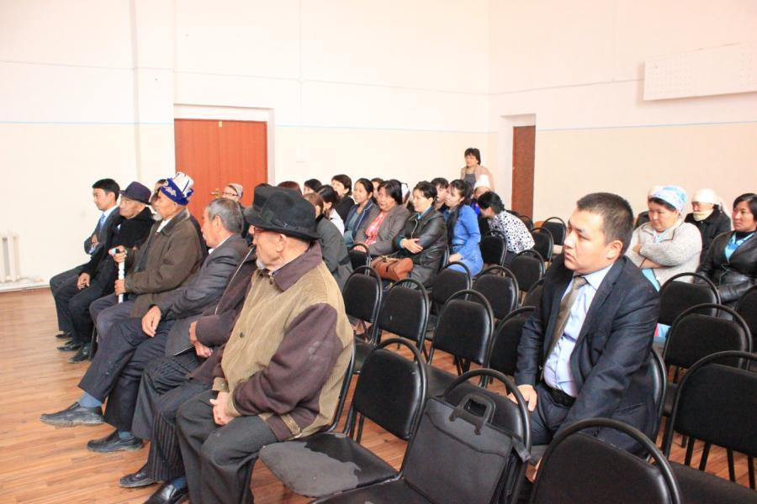
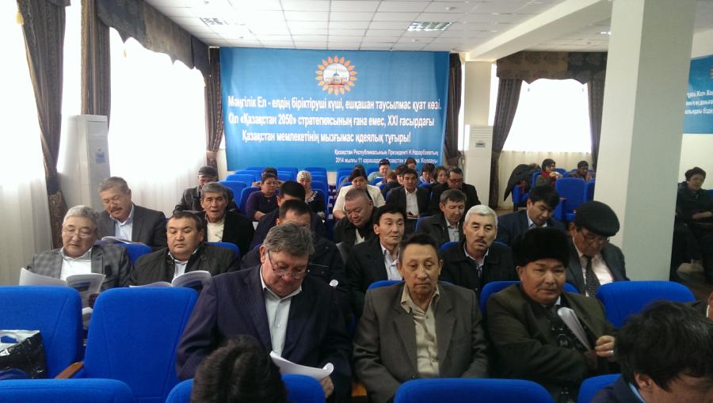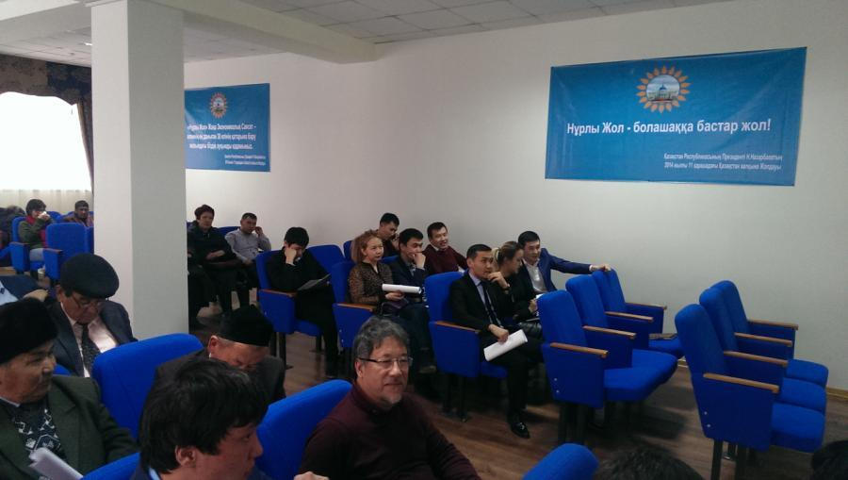
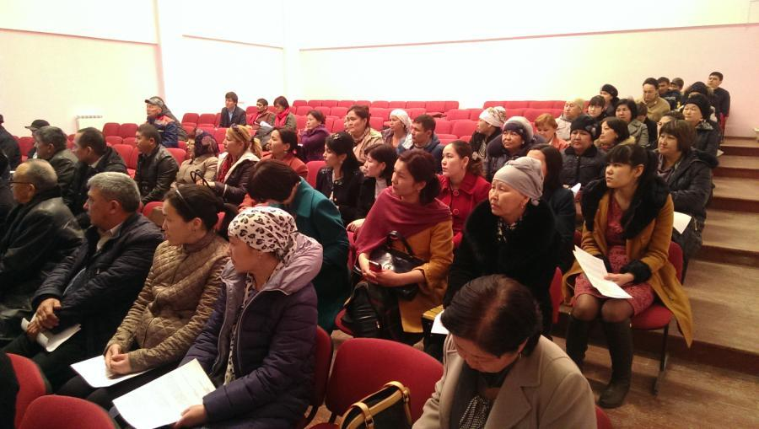

The Constitution was adopted in 30 August 1995 through republican referendum, came into effect on 5 September 1995. The amendments and additions were made by the Law of the Republic of Kazakhstan dated 7 October 1998, Law of the Republic of Kazakhstan dated 21 May 2007, Law of the Republic of Kazakhstan dated 2 February 2011.
Information on public consultations carried out in 2010-2011 was taken from the Environmental Impact Assessment report for Tranche 2 section of CAREC Corridor 2 (Mangystau Oblast Section) Investment Program, P43439-KAZ, July 2011

